 | Course Director:  Dr. Morgan Hale (fictional)  morgan.hale@meridian.example
BMS 501
Foundations of Infection and Immunity
Case 2: Jordan Rivera
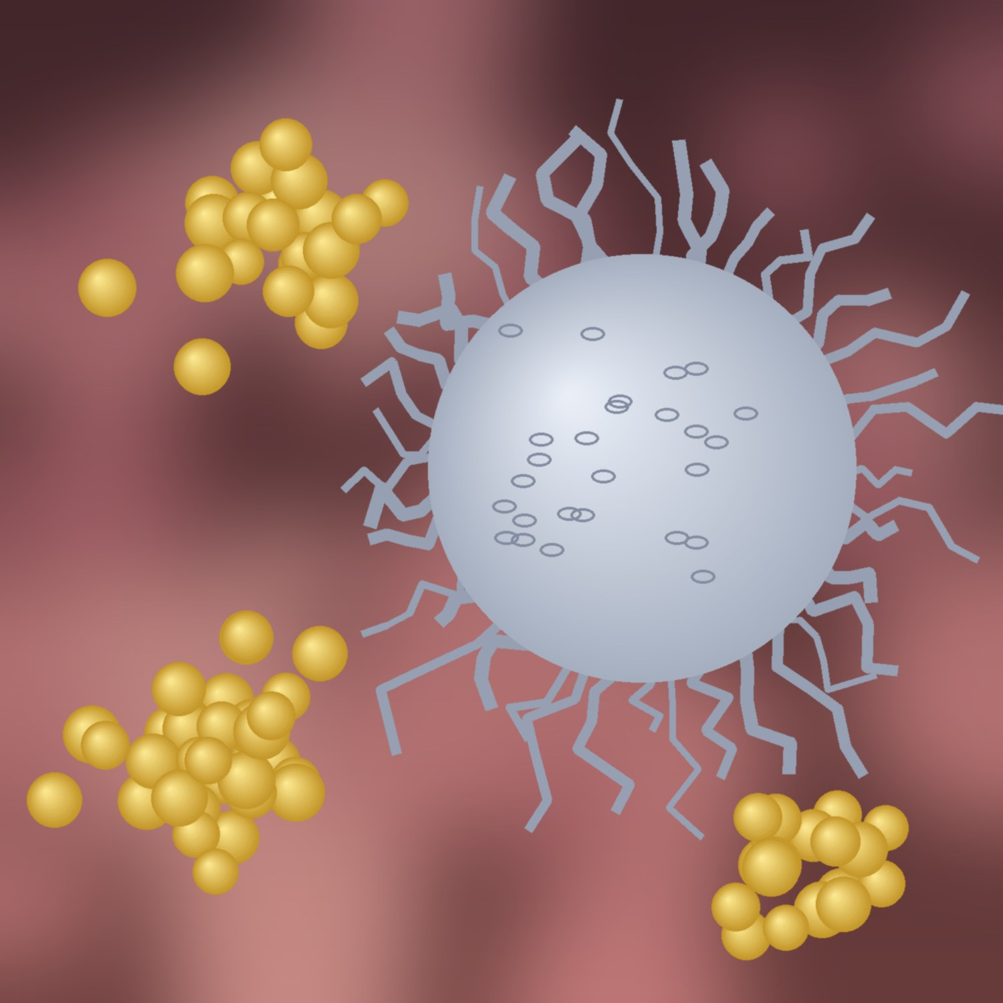
Meridian College of Medicine (fictional)

Table of Contents
Course Director Notes 3
Case Presentation 3
Immunology 4
Self-Study Topics: 5
Innate Defenses Against Skin Infection (TO-2101): 5
Videos: 5
Barriers and Pattern Recognition (TO-2101) (14:20) 5
Neutrophil Recruitment and Extravasation (TO-2101) (12:05) 5
Phagocytosis and Oxidative Killing (TO-2101) (10:42) 5
Slides: 5
Innate Immunity: Barriers, Recognition, and Neutrophils (TO-2101) 5
Notes: See Below 5
Learning Objectives: 5
Immunology: Self-Study Questions 6
Immunology: Self-Study Questions + Answers 6
Microbiology 6
Self-Study Topics: 7
Staphylococci and Methicillin Resistance (TO-2205): 7
Videos: 7
Staphylococci: Identification (TO-2205) (9:40) 7
S. aureus Virulence Factors and Toxins (TO-2205) (16:15) 7
MRSA: Mechanism and Epidemiology (TO-2205) (8:30) 7
Slides: 7
Staphylococcus aureus (TO-2205) 7
Notes: See Below 7
Learning Objectives: 7
Microbiology: Self-Study Questions 7
Microbiology: Self-Study Questions + Answers 8
Pharmacology 8
Self-Study Topics: 9
Antibiotics for Gram-Positive Infections (TO-2312): 9
Videos: 9
Cell Wall Inhibitors I: Beta-lactams (TO-2312) (13:10) 9
Cell Wall Inhibitors II: Vancomycin (TO-2312) (7:55) 9
Folate Antagonists and Tetracyclines (TO-2312) (11:20) 9
Slides: 9
Antibiotics for Gram-Positive Infections (TO-2312) 9
Notes: No Written Notes 9
Learning Objectives: 9
Pharmacology: Self-Study Questions 9
Pharmacology: Self-Study Questions + Answers 10
Selected References 10

Course Director Notes
Welcome to Case 2
This week follows Jordan Rivera, a college athlete with a painful skin infection. The case connects innate immunity, the virulence of Staphylococcus aureus, and how we choose antibiotics when resistance is possible.
Work through the case presentation first, then each discipline in order. Try every self-study question before you look at the answers.
Small-group session: Thursday, 9:00-11:00 (fictional).
This guide demonstrates AI-assisted study; follow your own school's AI policy for real course materials.

Case Presentation
Chief complaint
“There’s a painful bump on my arm that keeps getting bigger.”
History of present illness
Jordan Rivera is a 19-year-old college wrestler who presents to student health with a 4-day history of a red, swollen, painful lesion on the ulnar (medial) side of the right forearm. It began as what Jordan thought was a spider bite after practice. Over 48 hours it became firm and warm, and this morning it felt soft in the center. Jordan reports subjective fevers and fatigue. Two teammates had similar “boils” this season.
Past history
- No chronic illnesses; no prior hospitalizations
- Medications: none. Allergies: no known drug allergies
- Social: shares mats and towels at practice; no injection drug use
Vital signs
Measure | Value | Reference
Temperature | Value: 38.4 °C | Reference: 36.1-37.2 °C
Heart rate | Value: 104 /min | Reference: 60-100 /min
Blood pressure | Value: 118/72 mmHg | Reference: <120/80 mmHg
Respiratory rate | Value: 16 /min | Reference: 12-20 /min
SpO2 | Value: 99% room air | Reference: ≥95%

Physical examination
A 4 cm erythematous, warm, tender nodule on the ulnar side of the right volar forearm with a fluctuant center and 2 cm of surrounding erythema. No lymphangitic streaking. Small, tender right epitrochlear node. The rest of the exam is normal.
Laboratory results
Test | Result | Flag | Reference range | Units
WBC | Result: 14.2 | Flag: H | Reference range: 4.0-11.0 | Units: ×10³/µL
Neutrophils | Result: 82 | Flag: H | Reference range: 40-70 | Units: %
Band forms | Result: 6 | Flag: H | Reference range: 0-5 | Units: %
Lymphocytes | Result: 11 | Flag: L | Reference range: 20-40 | Units: %
Hemoglobin | Result: 14.6 | Flag: none | Reference range: 13.5-17.5 | Units: g/dL
Platelets | Result: 268 | Flag: none | Reference range: 150-400 | Units: ×10³/µL
C-reactive protein | Result: 48 | Flag: H | Reference range: <10 | Units: mg/L
Creatinine | Result: 0.9 | Flag: none | Reference range: 0.7-1.3 | Units: mg/dL
Glucose (random) | Result: 94 | Flag: none | Reference range: 70-125 | Units: mg/dL

Reference ranges are typical adult values (hemoglobin and creatinine shown for an adult male); they vary by laboratory.
Procedure and microbiology
Bedside incision and drainage released 6 mL of thick yellow pus. Gram stain showed many neutrophils and gram-positive cocci in clusters. Culture grew large golden colonies with beta-hemolysis on blood agar.
Test | Result | Interpretation
Catalase | Result: Positive | Interpretation: Staphylococcus
Coagulase | Result: Positive | Interpretation: S. aureus
Cefoxitin disk screen | Result: Resistant | Interpretation: mecA / PBP2a likely (MRSA)
Trimethoprim-sulfamethoxazole | Result: Susceptible | Interpretation: none
Doxycycline | Result: Susceptible | Interpretation: none
Clindamycin (D-test) | Result: Negative D-test; susceptible | Interpretation: none

Review the results above. Before reading on, write down: (1) the organism, (2) the host cells doing most of the work, and (3) what you would treat with and why.

Immunology
Discipline Director: Dr. Avery Lin (fictional)
avery.lin@meridian.example
Office hours: Tuesday 3:00-4:00 (fictional)
Discipline Director Notes:
- Focus on the first hours of infection: barriers, recognition, recruitment, and killing.
- Be able to trace a neutrophil from the bloodstream to the abscess.

Self-Study Topics:

Innate Defenses Against Skin Infection (TO-2101):

Videos:

Barriers and Pattern Recognition (TO-2101) (14:20)

Neutrophil Recruitment and Extravasation (TO-2101) (12:05)

Phagocytosis and Oxidative Killing (TO-2101) (10:42)

Slides:

Innate Immunity: Barriers, Recognition, and Neutrophils (TO-2101)

Notes: See Below

Learning Objectives:
1. Describe how skin acts as a physical, chemical, and microbial barrier.
2. Explain how pattern recognition receptors (TLR2) detect gram-positive bacteria.
3. Outline the steps of neutrophil recruitment: rolling, activation, adhesion, transmigration.
4. Explain how neutrophils kill bacteria with the respiratory burst.
5. Predict how S. aureus virulence factors interfere with each step.

Neutrophil Recruitment and Killing (LO-1102, LO-1103)
Recognition
- Bacterial lipoproteins are the main ligands for TLR2 (with TLR1 or TLR6); whether lipoteichoic acid also signals through TLR2 is debated [PMID:18406368].
- Tissue macrophages release IL-1, TNF-α, and IL-8 (CXCL8).
Recruitment (the leukocyte adhesion cascade)
Step | Endothelial molecule | Neutrophil molecule
Rolling | Endothelial molecule: E-selectin, P-selectin | Neutrophil molecule: Sialyl-Lewis X
Activation | Endothelial molecule: Chemokines (IL-8) | Neutrophil molecule: Chemokine receptors
Tight adhesion | Endothelial molecule: ICAM-1 | Neutrophil molecule: Integrins (LFA-1, Mac-1)
Transmigration | Endothelial molecule: PECAM-1 (CD31) | Neutrophil molecule: PECAM-1 (CD31)

Killing
- Opsonized bacteria (IgG, C3b) are phagocytosed and the phagosome fuses with lysosomes.
- NADPH oxidase produces superoxide (the respiratory burst); myeloperoxidase makes hypochlorite.
- Pus is mostly dead neutrophils, bacteria, and tissue debris.
Clinical correlation
- Chronic granulomatous disease (NADPH oxidase defect): recurrent S. aureus, Aspergillus, and other infections. Often taught as 'catalase-positive organisms', but in a mouse model catalase-negative S. aureus was equally virulent [PMID:11997027].
- Leukocyte adhesion deficiency type 1 (CD18 defect): little or no pus with marked neutrophilia; delayed umbilical cord separation is classic but not universal.

Immunology: Self-Study Questions
1. A neutrophil rolling along the endothelium near Jordan’s abscess is slowed by which endothelial molecule?
- A. ICAM-1
- B. E-selectin
- C. PECAM-1
- D. VCAM-1
- E. MHC class II
2. A child has recurrent S. aureus abscesses and absent superoxide production on a nitroblue tetrazolium (NBT) test. Which enzyme is defective?
- A. Myeloperoxidase
- B. NADPH oxidase
- C. Superoxide dismutase
- D. Catalase
- E. Lysozyme

Immunology: Self-Study Questions + Answers
1. A neutrophil rolling along the endothelium near Jordan’s abscess is slowed by which endothelial molecule?
- A. ICAM-1
- B. E-selectin
- C. PECAM-1
- D. VCAM-1
- E. MHC class II
Answer: B
Selectins mediate rolling; ICAM-1 binding to integrins mediates tight adhesion.
2. A child has recurrent S. aureus abscesses and absent superoxide production on a nitroblue tetrazolium (NBT) test. Which enzyme is defective?
- A. Myeloperoxidase
- B. NADPH oxidase
- C. Superoxide dismutase
- D. Catalase
- E. Lysozyme
Answer: B
No superoxide on NBT = absent respiratory burst = chronic granulomatous disease (NADPH oxidase defect). Myeloperoxidase deficiency spares superoxide production.

Microbiology
Discipline Director: Dr. Morgan Patel (fictional)
morgan.patel@meridian.example
Office hours: Wednesday 1:00-2:00 (fictional)
Discipline Director Notes:
- Know how to identify S. aureus in the lab and link each virulence factor to a disease.
- Practice the sample deck: sample/curriculum/MICRO/Staphylococcus aureus (sample lecture).pptx

Self-Study Topics:

Staphylococci and Methicillin Resistance (TO-2205):

Videos:

Staphylococci: Identification (TO-2205) (9:40)

S. aureus Virulence Factors and Toxins (TO-2205) (16:15)

MRSA: Mechanism and Epidemiology (TO-2205) (8:30)

Slides:

Staphylococcus aureus (TO-2205)

Notes: See Below

Learning Objectives:
1. Identify S. aureus using Gram stain, catalase, and coagulase.
2. Match surface factors (protein A, capsule, coagulase) to how they evade the host.
3. Distinguish toxin-mediated diseases: TSS, scalded skin syndrome, food poisoning.
4. Explain the mechanism of methicillin resistance (mecA, PBP2a).
5. Contrast community-associated and hospital-associated MRSA.

Staphylococcus aureus (LO-1201, LO-1202, LO-1203)
Factor | Type | Action | Disease link
Protein A | Type: Surface | Action: Binds Fc of IgG; blocks opsonization | Disease link: Immune evasion
Coagulase | Type: Enzyme | Action: Activates prothrombin, forming fibrin | Disease link: Fibrin wall around the abscess
Panton-Valentine leukocidin | Type: Toxin | Action: Pore-forming; kills leukocytes | Disease link: Associated with CA-MRSA skin infection and necrotizing pneumonia (causal role debated)
TSST-1 | Type: Superantigen | Action: Cross-links MHC II and TCR | Disease link: Toxic shock syndrome
Exfoliative toxin | Type: Protease | Action: Cleaves desmoglein-1 | Disease link: Scalded skin syndrome
Enterotoxin | Type: Superantigen; heat-stable | Action: Preformed toxin in food | Disease link: Vomiting 30 min-8 h after eating (mean about 3 h)

Methicillin resistance
- mecA (on SCCmec) encodes PBP2a, a penicillin-binding protein with low affinity for beta-lactams.
- MRSA is resistant to nearly all beta-lactams (exception: anti-MRSA cephalosporins such as ceftaroline).
- Community-associated strains often carry PVL (its role in virulence is debated) and cause skin abscesses in healthy young people, especially with shared equipment and skin contact (athletes, dormitories) [PMID:17146447][PMID:22759601].

Microbiology: Self-Study Questions
1. Which test distinguishes S. aureus from coagulase-negative staphylococci?
- A. Catalase
- B. Coagulase
- C. Optochin
- D. Bacitracin
- E. Bile solubility
2. Jordan’s isolate is cefoxitin-resistant. What is the molecular basis?
- A. Beta-lactamase hyperproduction
- B. Altered PBP (PBP2a) encoded by mecA
- C. Efflux pump
- D. D-Ala-D-Lac cell wall precursor
- E. Decreased porin expression

Microbiology: Self-Study Questions + Answers
1. Which test distinguishes S. aureus from coagulase-negative staphylococci?
- A. Catalase
- B. Coagulase
- C. Optochin
- D. Bacitracin
- E. Bile solubility
Answer: B
All staphylococci are catalase positive; among human isolates, S. aureus is the coagulase-positive species.
2. Jordan’s isolate is cefoxitin-resistant. What is the molecular basis?
- A. Beta-lactamase hyperproduction
- B. Altered PBP (PBP2a) encoded by mecA
- C. Efflux pump
- D. D-Ala-D-Lac cell wall precursor
- E. Decreased porin expression
Answer: B
PBP2a binds beta-lactams poorly, so cell-wall synthesis continues.

Pharmacology
Discipline Director: Dr. Riley Okafor (fictional)
riley.okafor@meridian.example
Office hours: Friday 10:00-11:00 (fictional)
Discipline Director Notes:
- Know how each anti-staphylococcal drug works and when MRSA changes the choice.
- Incision and drainage is the main treatment for an abscess. Jordan has fever and tachycardia (two SIRS criteria), so an MRSA-active antibiotic is indicated [PMID:24973422]. In a large trial, TMP-SMX after drainage also raised the cure rate of uncomplicated abscesses (80.5% vs 73.6% with placebo, modified intention-to-treat) [PMID:26962903].
Summary of Important Symbols and Parameters
Symbol | Meaning | Formula
Vd | Meaning: Volume of distribution | Formula: Dose / C0
CL | Meaning: Clearance | Formula: Rate of elimination / plasma concentration
t½ | Meaning: Half-life | Formula: 0.693 × Vd / CL
Css | Meaning: Steady-state concentration | Formula: Dosing rate / CL
LD | Meaning: Loading dose | Formula: Css × Vd / F

Self-Study Topics:

Antibiotics for Gram-Positive Infections (TO-2312):

Videos:

Cell Wall Inhibitors I: Beta-lactams (TO-2312) (13:10)

Cell Wall Inhibitors II: Vancomycin (TO-2312) (7:55)

Folate Antagonists and Tetracyclines (TO-2312) (11:20)

Slides:

Antibiotics for Gram-Positive Infections (TO-2312)

Notes: No Written Notes

Learning Objectives:
1. Explain how beta-lactams and vancomycin inhibit cell-wall synthesis, and why each fails against resistant organisms.
2. Choose an oral agent for uncomplicated CA-MRSA skin infection and justify it.
3. Name key adverse effects of vancomycin, TMP-SMX, and doxycycline.
4. Calculate a loading dose from Vd and a target concentration.
Drug | Target | Covers MRSA? | Key adverse effects
Nafcillin / oxacillin | Target: PBPs (beta-lactamase resistant) | Covers MRSA?: No | Key adverse effects: Neutropenia; interstitial nephritis (rare)
Cefazolin | Target: PBPs | Covers MRSA?: No | Key adverse effects: Hypersensitivity
Vancomycin | Target: Binds D-Ala-D-Ala | Covers MRSA?: Yes | Key adverse effects: Nephrotoxicity; infusion reaction (flushing)
TMP-SMX | Target: DHFR + dihydropteroate synthase | Covers MRSA?: Yes | Key adverse effects: Hyperkalemia, rash, bone marrow suppression
Doxycycline | Target: 30S ribosome | Covers MRSA?: Yes | Key adverse effects: Photosensitivity, esophagitis; avoid in pregnancy

Pharmacology: Self-Study Questions
1. After drainage, Jordan is sent home on an oral antibiotic. Which is most appropriate given the susceptibilities?
- A. Dicloxacillin
- B. Cephalexin
- C. Trimethoprim-sulfamethoxazole
- D. Amoxicillin
- E. Penicillin V
2. A drug has Vd = 50 L and target concentration 20 mg/L with F = 1. What loading dose is needed?
- A. 100 mg
- B. 250 mg
- C. 1,000 mg
- D. 2,500 mg
- E. 5,000 mg

Pharmacology: Self-Study Questions + Answers
1. After drainage, Jordan is sent home on an oral antibiotic. Which is most appropriate given the susceptibilities?
- A. Dicloxacillin
- B. Cephalexin
- C. Trimethoprim-sulfamethoxazole
- D. Amoxicillin
- E. Penicillin V
Answer: C
The isolate is MRSA and TMP-SMX susceptible; beta-lactams do not cover MRSA.
2. A drug has Vd = 50 L and target concentration 20 mg/L with F = 1. What loading dose is needed?
- A. 100 mg
- B. 250 mg
- C. 1,000 mg
- D. 2,500 mg
- E. 5,000 mg
Answer: C
LD = Css × Vd / F = 20 mg/L × 50 L = 1,000 mg.

Selected References
Every reference below was checked in PubMed. A citation shows a source exists; open it to see whether it supports the claim.
- Stevens DL, et al. IDSA practice guidelines for skin and soft tissue infections, 2014 update. [PMID:24973422]
- Talan DA, et al. Trimethoprim-sulfamethoxazole versus placebo for uncomplicated skin abscess. N Engl J Med 2016. [PMID:26962903]
- Malachowa N, Kobayashi SD, DeLeo FR. Community-associated MRSA and athletes. Phys Sportsmed 2012. [PMID:22759601]
- Amagai M, et al. Toxin in bullous impetigo and staphylococcal scalded-skin syndrome targets desmoglein 1. Nat Med 2000. [PMID:11062541]
- Boyle-Vavra S, Daum RS. Community-acquired MRSA: the role of Panton-Valentine leukocidin. Lab Invest 2007. [PMID:17146447]
- Zähringer U, et al. TLR2 - promiscuous or specific? Immunobiology 2008. [PMID:18406368]
- Messina CG, et al. Catalase negative S. aureus retain virulence in a mouse model of CGD. FEBS Lett 2002. [PMID:11997027]

